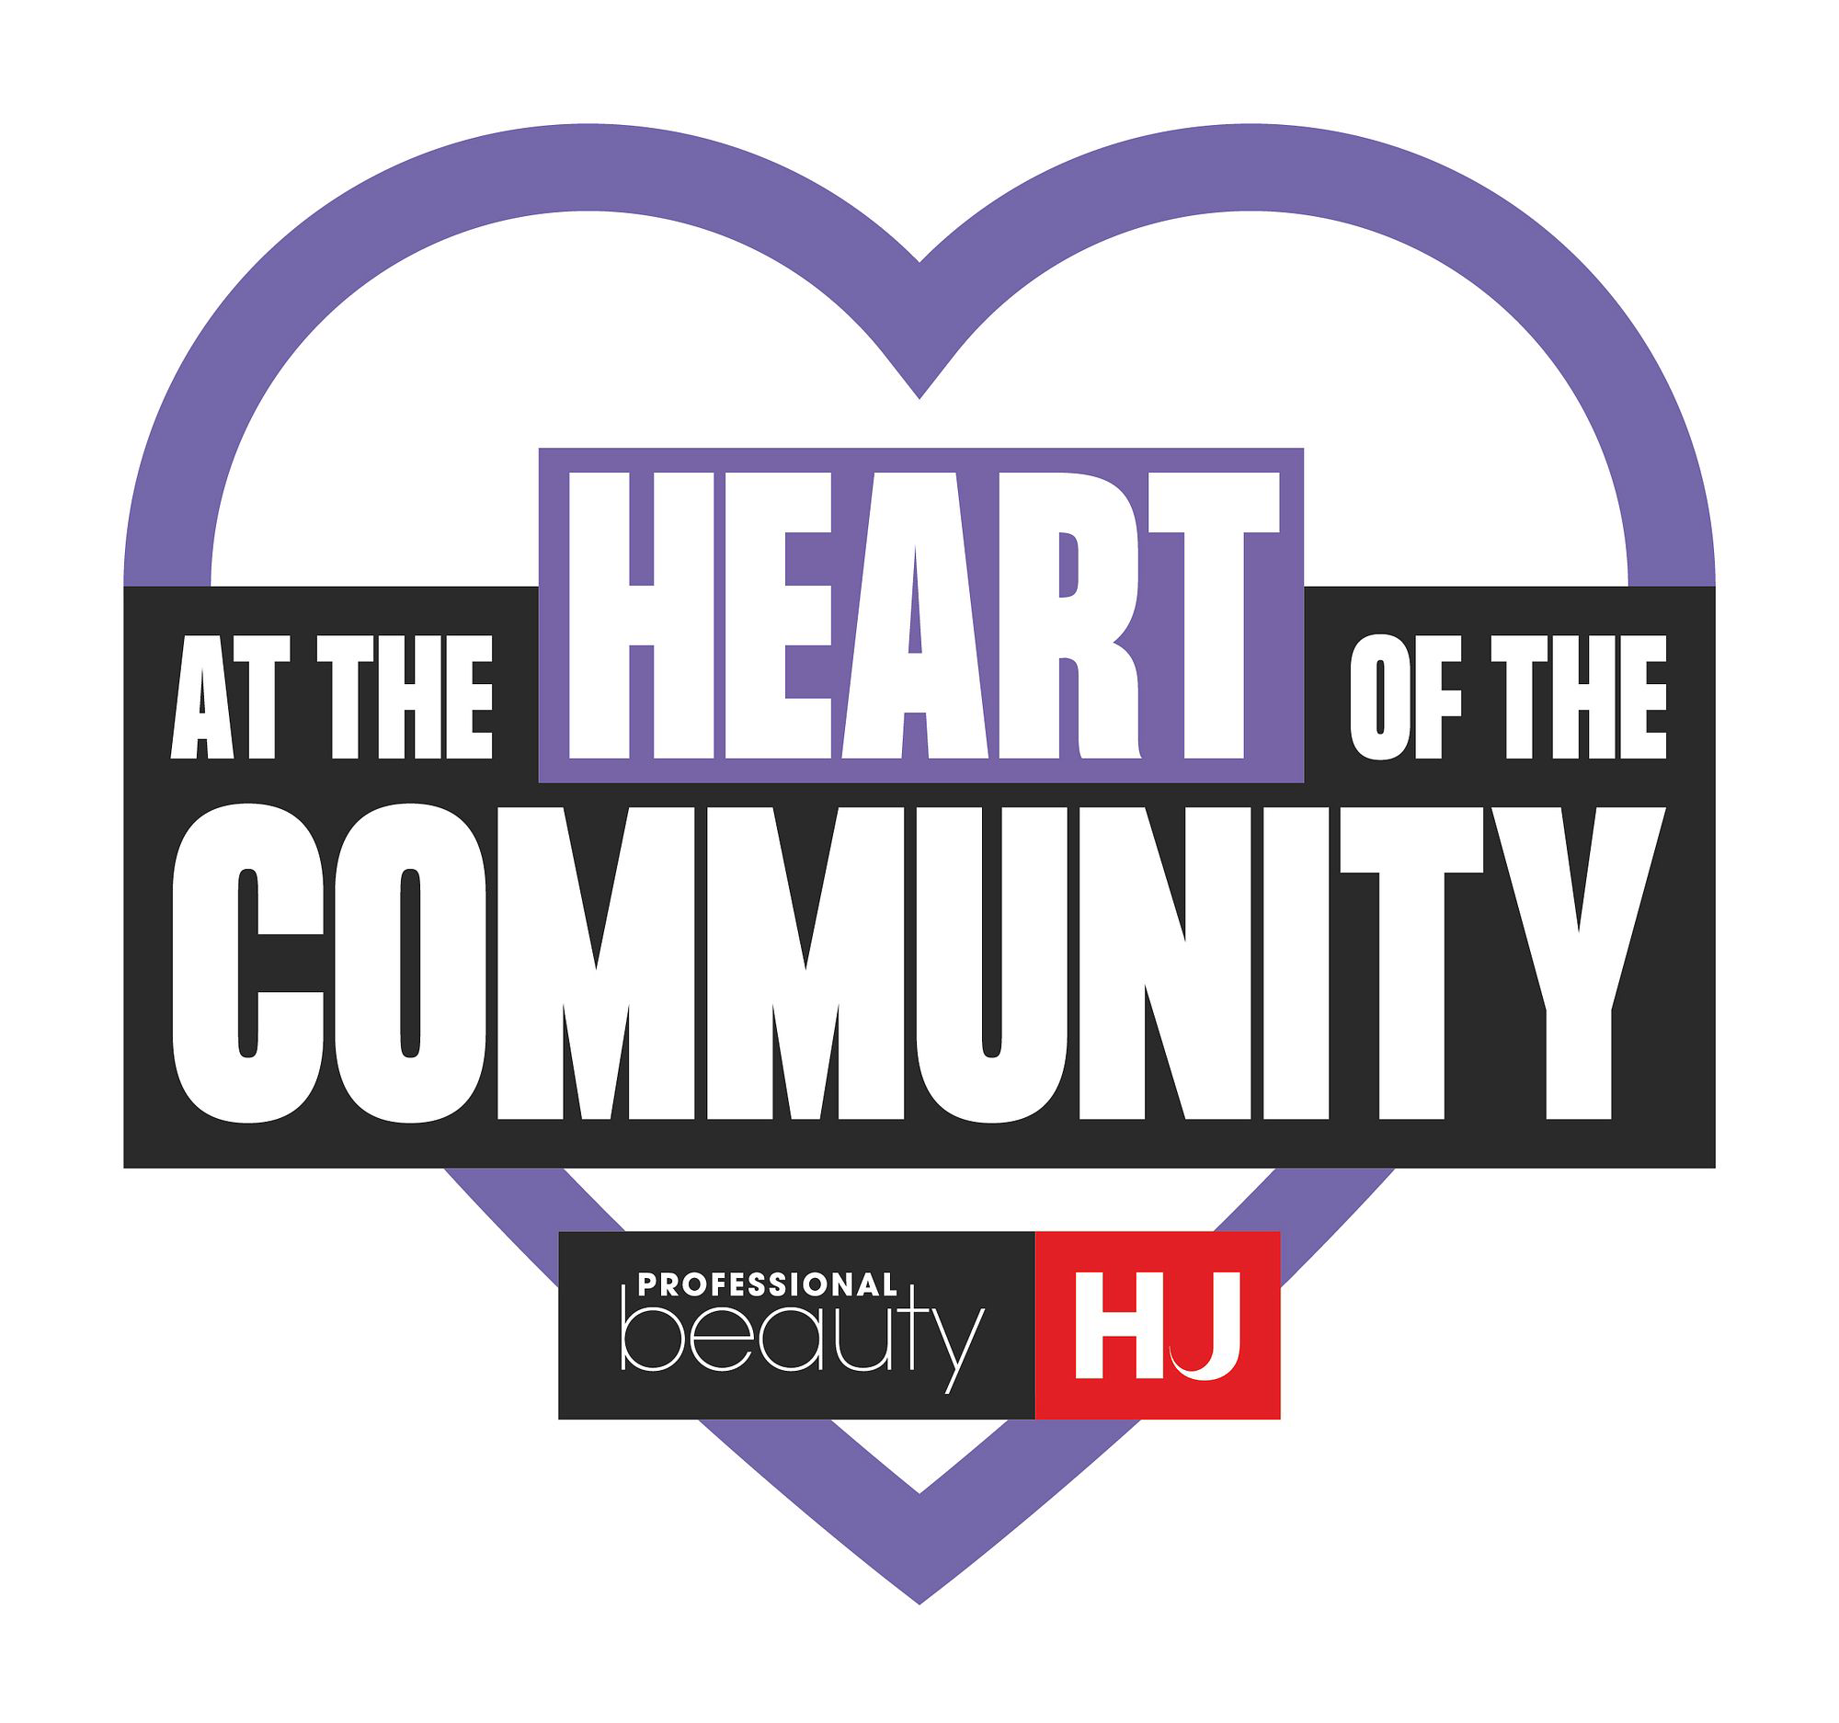
Email to local media

Subject: Local story and salon visit: the pressures facing [TOWN]’s high-street businesses
Hello [JOURNALIST/EDITOR NAME],
I’m [NAME], owner of [SALON NAME], a [beauty salon/hair salon/barbershop] based in [TOWN].
I’m getting in touch with a potential local business story about the pressures facing salons and barbershops, and what could be lost from communities if these businesses become unable to remain sustainable.
Our business [EMPLOYS NUMBER OF LOCAL PEOPLE/TRAINS APPRENTICES/ADD ANOTHER LOCAL CONTRIBUTION]. We bring clients into [TOWN/AREA] throughout the week and have built long-standing relationships with the community.
However, rising operating and employment costs and business rates, alongside the impact of VAT on VAT-registered businesses, are making it increasingly difficult for businesses like ours to invest, recruit and train.
We are taking part in At The Heart Of The Community, a Professional Beauty Group campaign raising awareness of the economic and social contribution made by salons and barbershops across the UK.
I have attached a press release with further information and national figures. I would be happy to discuss what these pressures mean for a local business and the people it employs.
You would also be very welcome to visit [SALON NAME], meet the team and take photographs by prior arrangement.
Please let me know if this could be of interest.
Best wishes,
[NAME]
[SALON NAME]
[EMAIL]
[TELEPHONE]
[WEBSITE/INSTAGRAM]

