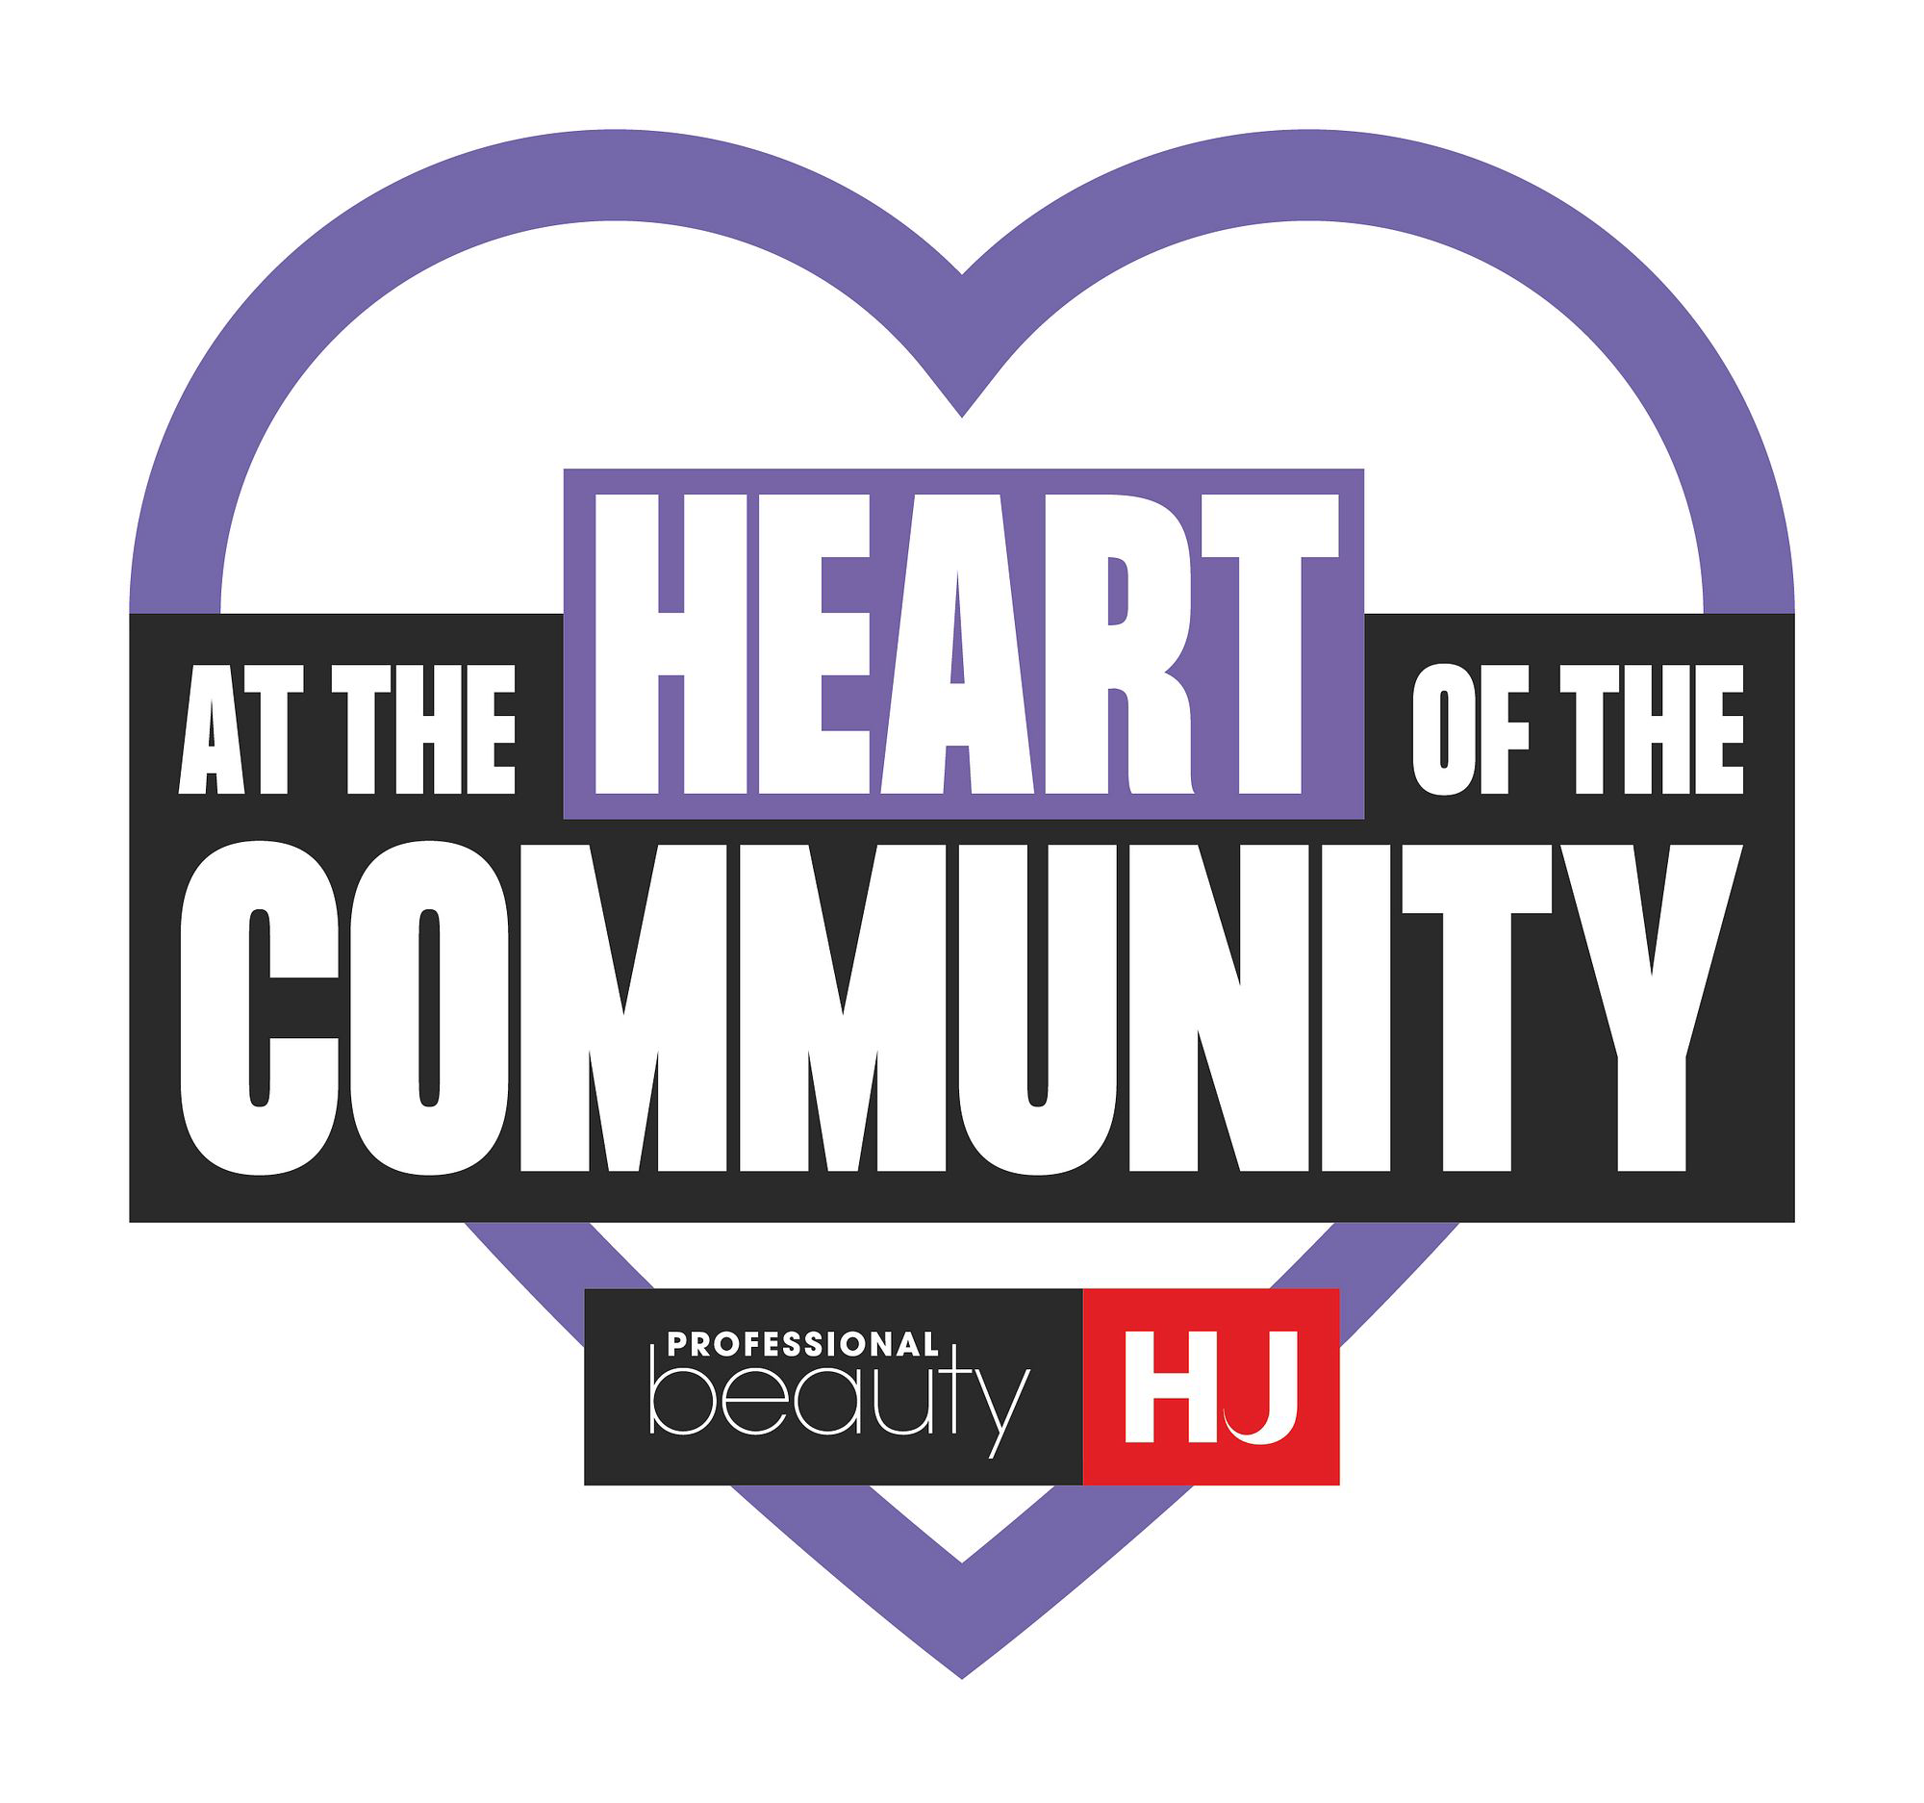
Press release for local media

FOR IMMEDIATE RELEASE

LOCAL [SALON/BARBERSHOP] CALLS FOR GREATER SUPPORT FOR BUSINESSES AT THE HEART OF [TOWN/AREA]
[Optional alternative headline: [SALON NAME] highlights pressures facing local salons and barbershops]
[DATE] – [SALON NAME], a [beauty salon/hair salon/barbershop] based in [TOWN/AREA], is calling for greater recognition of the economic and community value of salons and barbershops as businesses across the sector face continued cost pressures.
The business is supporting At The Heart Of The Community, a Professional Beauty Group campaign raising awareness of the contribution hair and beauty businesses make to employment, skills and high streets throughout the UK.
Salons and barbershops are regular sources of footfall for town centres and neighbourhoods. They provide local jobs, offer routes into work through apprenticeships and training, and build long-standing relationships with the communities they serve.
The latest Value of Beauty report, commissioned by the British Beauty Council and compiled by Oxford Economics, found that beauty services, including hairdressing and beauty therapies, directly contributed £5.7 billion to UK GDP in 2025 and directly employed 243,000 people.
Despite that contribution, many businesses are navigating a combination of rising operating and employment costs, business rates and the impact of VAT.
Businesses must generally register for VAT once their taxable turnover exceeds £90,000, after which most salon services are subject to the standard 20% rate. Because salons are highly labour-intensive and cannot reclaim VAT on wages, crossing the threshold can have a particularly significant effect on margins and prices.
The sector is also concerned about its future workforce. Department for Education figures show that apprenticeship starts on the Hair and Beauty route in England fell by more than 1,500 in 2024/25 compared with the previous academic year.
[OWNER NAME], owner of [SALON NAME], said:
“[ADAPT THIS QUOTE TO REFLECT YOUR BUSINESS: Our [salon/barbershop] is part of the everyday life of [TOWN/AREA]. We employ local people, support people entering the industry and bring clients into the area throughout the week.
“We are proud of the contribution we make, but the cost of running a people-focused business has risen considerably. We want to continue investing in our team and community, but we need VAT, business rates and apprenticeship support to reflect the realities facing small, labour-intensive businesses.]”
[SALON NAME] is asking local and national decision-makers to listen to business owners and consider measures that support sustainable employment and training within the sector. These include a fairer approach to VAT for labour-intensive services, proportionate business rates and stronger incentives for businesses taking on apprentices.
[ADD TWO OR THREE SENTENCES ABOUT YOUR BUSINESS. FOR EXAMPLE: SALON NAME opened in YEAR and employs NUMBER people. It offers SERVICES and has supported its local community by DETAILS.]
ENDS

Media contact
[NAME]
[SALON NAME]
[EMAIL]
[TELEPHONE]
[WEBSITE/INSTAGRAM]
[ADDRESS]

Notes to editors
- [SALON NAME] is a [beauty salon/hair salon/barbershop] based in [TOWN/AREA].
- The owner and team are available for interview.
- Journalists are welcome to visit the business, meet the team and photograph the salon by prior arrangement.
- At The Heart Of The Community is a Professional Beauty Group campaign highlighting the economic and community contribution made by salons and barbershops.
- The Value of Beauty 2026 report was commissioned by the British Beauty Council and compiled by Oxford Economics. It reports on the industry’s contribution during 2025.
- UK VAT registration is generally compulsory when taxable turnover exceeds £90,000. Most salon services supplied by VAT-registered businesses are subject to the standard 20% rate.
- The latest complete Department for Education apprenticeship statistics show that Hair and Beauty apprenticeship starts in England fell by more than 1,500 in 2024/25 compared with 2023/24.

